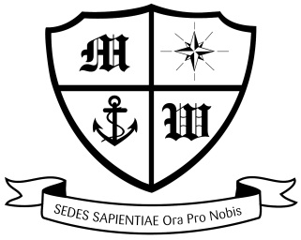
MUCH WOOLTON CATHOLIC PRIMARY SCHOOL

17/10/2019

Bedtime Stories

Dear Parents/Families,

On Thursday 21st November, we will once again perform our popular 'Bedtime Stories' workshop, where children have the opportunity to stay behind after school and wear their pyjamas to listen to teachers reading their favourite books. This activity helps to promote a love of books and reading with children and will hopefully be as successful and as memorable as the previous sessions.

The session will begin at 3.45pm and last for an hour. All children participating will need to be collected from the front of school at 4.45pm. We would appreciate if you could be punctual in collecting your child at this time. Please note, that there is no charge for this session.

If you would like your child to participate in the Bedtime Stories session, please complete the form below and return it to your class teacher as soon as possible.

Many thanks for your continued support.

Miss Doherty and Mr Strode

I would like my son/daughter ______________________________________ Class _______________

to attend the Bedtime Stories session on Thursday 21st November 2019. Signed ___________________

