

Reading at Much Woolton

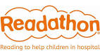http://t1.gstatic.com/images?q=tbn:ANd9GcRgwiX1xSReflB5yS9JFAG58FOu7aqlc8I_3zKw0alTSSKa-ig_El4ZPfA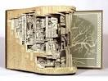http://t2.gstatic.com/images?q=tbn:ANd9GcRVTC2yxtc_stxUAFhaHpxGP3A5K5y5Wn1c6USyyOJVLYS_DbEO4IZeztI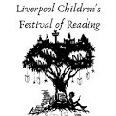This is what reading looks like at our school:

* Reading Plus Programme
* Whole Class Guided Reading
* Whole Class Novels
* Quality Text Approach
* Oxford Reading Tree Scheme
* Read, Write, Inc Scheme
* Book Bag Books
* Parent and Carer Stay and Read Sessions
* Reading and Recycling
* World Book Day
* Liverpool Festival of Reading
* Indoor and Outdoor Reading Areas
* Library Time
* Author visits
* Liverpool Readathon
* Drop Everything and Read