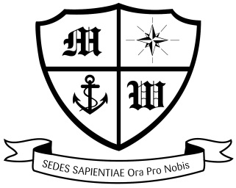
MUCH WOOLTON CATHOLIC PRIMARY SCHOOL

Thursday 13th September

Dear Parents and Families,

LIVERPOOL PRIMARY SCHOOLS’ SKI COURSES 2019
Saturday 26th January to Saturday 2nd February 2019:
Hotel Mont Corbier, in Le Corbier.

A payment of £100 was due on 7th September. If you haven’t already done so, please pay this overdue amount to the office as soon as possible. A further payment of £100 is due on Friday 28th September taking the payments to £600.

A reminder that a ski clothing meeting will be held at Much Woolton on Friday 28th September at 3:45, at which all essential items of clothing will be available for purchase. At this meeting you can also arrange hire of a ski jacket and ski trousers (salopettes) at very reasonable prices.

We are still awaiting several passports. Please send in your child’s passport immediately to the office. It will be checked to ensure it is valid and returned to you on the same day. Without passports, we are not able to book flights!

Thank you to those parents who have made all the required payments. May I also take this opportunity to remind you that if at any time you decide to remove your child from the trip, payments are due up until the date of cancellation and the cancellation must be made in writing.

Thank you your continued support,

Mrs Moorcroft
Ski Course Leader

