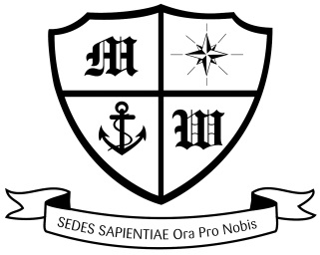
MUCH WOOLTON CATHOLIC PRIMARY SCHOOL

Friday 28th September

Dear Parents and Families,

LIVERPOOL PRIMARY SCHOOLS’ SKI COURSES 2019
Saturday 26th January to Saturday 2nd February 2019:
Hotel Mont Corbier, in Le Corbier.

A payment of £100 is due TODAY, Friday 28th September. If you haven’t already done so, please pay this amount to the office as soon as possible. This amount takes payments to £600. The final payment of £80 is due by Monday 29th October.

We are still awaiting several passports. Please send in your child’s passport immediately to the office. It will be checked to ensure it is valid and returned to you on the same day. Without passports, we are not able to book flights!

Thank you to those parents who have made all the required payments. May I also take this opportunity to remind you that if at any time you decide to remove your child from the trip, payments are due up until the date of cancellation, so £600, and the cancellation must be made in writing.

Please find attached medical and information gathering forms which you should complete and return to school no later than Friday 5th October.

Thank you your continued support,

Mrs Moorcroft
Ski Course Leader

