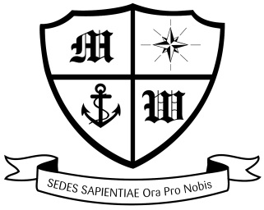
MUCH WOOLTON CATHOLIC PRIMARY SCHOOL

Friday 6th July

Dear Parents and Carers

LIVERPOOL PRIMARY SCHOOLS’ SKI COURSES 2019

Saturday 26th January to Saturday 2nd February 2019:
Hotel Mont Corbier, in Le Corbier.

Attached is the Parents’ handbook that gives a great deal of information about the course. Please read the contents of this booklet carefully.

Many thanks to all those parents who have sent in their child’s passport or advised that a new one is being ordered. If you have not done so, I need to see it by Tuesday 10th July.

Thank you to those parents who have made the third payment which was due on the 26th June. The payments to date now total £300 with a further payment of £100 being due no later than Monday 16th July. For those who haven’t made the overdue June payment, please pay it IMMEDIATELY as school have now paid this on your behalf. Non-payment will jeopardise your child’s place on the ski course.

May I also take this opportunity to remind you that if at any time you decide to remove your child from the trip, payments are due up until the date of cancellation and the cancellation must be made in writing.

Thank you your continued support,

Mrs Moorcroft
Ski Course Leader

