Appendix A
Risk Assessment

A | Date: 11 June 2021 | School: Much Woolton | Team: | Location:
 | Review Date: 25 June 2021 | Ref: | Assessor: MW/ MWi | Head Teacher: M White

B | Assessment of Risk for: Protection from transmission of Covid-19 during pandemic including all school activities

C | List Hazards Here | List Groups of  People at Risk | List Existing Controls | Risk Level
Ser Nº
1 | Covid-19 virus: General | Staff  Pupils  Visitors  Contractors | All staff are competent and instructed with regard to the procedures in place for the protection against infection from the virus.  There is adequate supervision, where required, to ensure procedures are correctly adhered to.  Liverpool City Council COVID-19: Personal Protective Equipment (PPE) Policy  Reference School infection control risk assessment, as required: RA29  Pupils who are symptomatic will not be allowed to attend school.  Parents and secondary aged children will be required to wear face masks on entering the site  Visitors and contractors are allowed entrance to the school, however these should be kept to a minimum. All visitors and contractors must report to the office and confirm that they have not been COVID symptomatic in the previous 48 hours.  Parent and families should not enter the school building unless deemed necessary by staff at this time.  All visitors must wear a mask when in common usage areas (such as corridors) and must maintain social distancing when in a room. All rooms should be well ventilated during meetings with doors and windows open.  Meetings that are confidential in nature should be held in a room where windows can provide adequate ventilation.  Pupils with parents exhibiting symptoms will not be allowed to attend school and will be requested to isolate as per national guidance  Managers must also review all of the following applicable individual risk assessments where relevant:  - New and expectant mothers  - Extended duty of care  - Stress  - Individual Pupil assessments  Covid-19 specific extended duty of care risk assessment considered and carried out where relevant for all staff meeting the following criteria:  - Vulnerable member of staff who have received a Government shielded letter.  - Staff who have an extremely vulnerable household member.  Questionnaire sent out to relevant staff  Formal process in place for manager/colleagues to contact the worker if required, as detailed within applicable risk assessment above.  Manager to regularly update and inform staff re government guidance regarding covid-19 controls required:  - Gov.uk https://www.gov.uk/  - Public Health England https://www.gov.uk/government/organisations/public-health-england  - Department for Education https://www.gov.uk/government/organisations/department-for-education  - Health and Safety Executive https://www.hse.gov.uk/  Referring to the following guidance and publications, as applicable:  - HSE COVID19 latest information and advice  - HSE Working safely during the coronavirus guide  - Government guidance COVID-19: guidance for schools and other educational settings  - Government guidance COVID-19: guidance on shielding and protecting people defined on medical grounds as extremely vulnerable  - Government guidance COVID-19: guidance on shielding and protecting people who are clinically extremely vulnerable  - Government publication COVID-19: cleaning in non-healthcare settings  - Government publication Best Practice: how to hand wash  Due to the rapidly changing advice on Covid-19, managers should ensure they review safe working procedures and protocols daily, until such time when it is deemed unnecessary.  There is an adequate supply of disposable PPE, as per specific task requirements, and all staff provided with instruction in the correct use and fitment:  - Public Health England and NHS YouTube video, Covid-19: putting on and removing personal protective equipment (PPE) – a guide for care homes  PPE provided, as required following specific current guidance for the protection of Covid-19 detail type and standard, as applicable:  - Disposable half face masks: ………  - Disposable gloves: ………  - Disposable aprons: ………  - Where personal care is to be provided eye protection/surgical face mask: ………  - detail any other specific disposable PPE in use  All used PPE should be double bagged and disposed of appropriately.  All staff informed that hands should be washed regularly as per Government guidance.  Pupils regularly reminded, in age appropriate ways, that hands should be regularly washed as per Government guidance.  Additional personal storage for change of clothes for staff due to alternative travel getting into work e.g. cycling, walking, running.  Parents and Guardians kept informed via email bulletins etc. regarding proposals for reopening including start finish times and any new local rules regarding drop of and pick up etc.  Staff kept informed via email, online meetings etc.  Post-incident de-briefing carried out for anyone involved in an incident of suspected contamination, with the aim of providing support and preventing incident recurrence. Further support provided to all staff members affected by the incident.  All incidents reported to the Health and Safety Unit, using the LCC online accident and incident report form.  Reference made to HSE guidance for reporting under RIDDOR:  - HSE RIDDOR reporting of COVID-19 |  | Low  Low  Low  Low  Low-  Low  Low  Low  Low  Low  Low  Low  Low  Low  Low  Low  Low  Low  Low
2 | Covid-19 virus; General school environment | Staff  Pupils  Visitors  Contractors | Additional school gates will be opened to the school grounds to dilute the numbers coming through them as much as possible.  Markings are laid out on the playground for classes to line up at the start of the school day – lines laid out to maintain social distancing.  School first aid risk assessment to be reviewed, as required: 1st Aid during COVID 19  There is hand sanitizer at the side of the touchscreen for staff and visitors to cleanse hands after signing in.  Wipes are with each photocopier and staff are asked to wipe each machine after each use.  Signage installed to various areas of the building reminding people to wash hands regularly, in line with Government guidance and to maintain 2m social distance.  Corridors, walkways and staircases have signs on walls indicating a one way system. Staff have verbally instructed children around this and new children receive induction on the new system.  One way system on stairwells .  No children enter admin corridor unaccompanied  Staff and pupils are requested to keep close to the side of the corridor or walkway to maximise social distancing while others are using the opposite side.  Classrooms have been laid out so that some social distancing (in all directions) can be maintained where possible. KS2 classrooms tables in rows all facing front, staggered and spaced out where possible.  KS1 classroom where this allows also. This does not apply in EYFS.  Children should not work face to face at in in KS2 and where possible in KS1 to minimise risk  - Pupils will then be kept in their bubbles and should not mix with other groups during the day. Each bubble will be a year group.  - Wherever possible, staff supervising a cohort should also remain within this ‘bubble’  Classes should be kept together and mixing with other classes minimised, as much as possible. Year group bubbles allowed to mix at break and lunchtime.  All classes are to take place in the same setting wherever possible to limit the numbers moving around the school.  Timetables should be revised where possible to reduce movement around the school premises and to stagger busy transitional periods.  Break and lunchtime rotas in place to allow staggered transition.  Dining room be laid out to maintain 2m social distancing as far as is reasonable practicable between 2 separate bubbles.  Queue tapes applied to dining room to indicate social distancing in the line for school dinners. Separate lines and pick up points for cutlery, plates and food.  Dining room tables and chairs will be wiped down as much as possible between sittings.  Lunch staff to wipe down tables and chairs  Soft furnishings, soft toys and toys that are hard to clean (such as those with intricate parts) are removed from classrooms and stored elsewhere.  All unnecessary items are removed from classrooms and teaching environments as much as possible.  Staff room has a maximum capacity of 9 adults, seated or standing.  Staff have own hot drink cups plates and cutlery to minimise use of staff room.  Breakfast Club- bubbles kept 2m apart in the hall. Doors and windows open. Limited movement around the hall. Children within each bubble pour own cereal and milk and collect dishes together at the end of eating. Staff to maintain 2m distancing from bubbles.  SBM office for 2 people maximum. Window to be opened during meetings. SBM will wear a mask during meetings. Meetings max 15 mins in length. | Low  Low  Low  Low  Low  Low  Low  Low  Low  Low  Low  Low  Low  Low  Low  Low  Low  Low  Low  Low  Low  Low  Low
2A | Face coverings | Staff  Necessary Visitors or contractors | All adults must wear a face mask (not a visor) when in indoor shared spaces (with the exception of classrooms) where 2m social distancing cannot be maintained. This includes offices, staffroom, corridors, toilets.  In offices and staffroom where seated arrangements ensure 2m distancing, face masks must be worn when individuals leave their seats.  In the kitchen, staff serving children must wear a face mask but these are not needed as long as 2m distancing is maintained between staff.  Lunch staff will need to also wear masks whilst working in the dining room.
3 | Covid-19 virus; School day | Staff  Pupils  Visitors  Contractors | EYFS- Use Car park entrance from 8.30am, pick up from here at 3.15pm with siblings from main hall  Y1+2 plus siblings children use main children’s gate from 8.45am onwards.  Y3+4 children use children’s gate from 8.55am  Y5 use Watergate Lane pedestrian gate from 8.45am.- supervision over traffic from 8.45am outside gates is needed  Y6 use Watergate Lane pedestrian gate from 8.45am.- supervision over traffic from 8.45am outside gates is needed  All other children aside from EYFS and siblings will be picked up at 3.30pm from 12 April.  Parents are requested to drop their children off alone i.e. not both parents attending at once. Keep parents updated with any changes to routines.  Parents are requested not to gather at entrance gates or doors, or enter the site (unless they have a pre-arranged appointment) once their children have entered the school. Keep parents updated with any changes to routines.  Parents follow 1 way system and gain entrance to site through Children’s entrance in 12’s, socially distanced.  Parents circulate exterior of the school from main children’s entrance to the pedestrian entrance from 3.30pm onwards as they exit the school, collecting children on their way.  Classes should be kept together thereby minimising mixing with other classes as much as possible.  Break times (including lunch) staggered for classes to minimise mixing and dilute numbers using common areas such as walkways and toilets.  Where possible the numbers using toilets will be managed in line with social distancing guidelines | Low  Low  Low  Low  Low  Low  Low  Low  Low  Low  Low
4 | Educational and extra curricular activities | Staff  Pupils  Visitors  Contractors | From 12 April 2021:  Staff may now organise day trips for class/ year bubbles to take place in the second half of the summer term, subject to COVID regulations.  Staff may also organise educational visitors into school who must adhere to COVID guidance in school, as laid out in this risk assessment. (Section 1)  Staff may organise extracurricular clubs and activities for year group bubbles only.  Staff may organise year group bubbles competitions against other schools who maintain their bubbles. Each individual activity and competition must be fully risk assessed, with a copy submitted to Evolve from approval by SMT prior to the event taking place. | Low  Low  Low
5 | Covid-19 virus; Working and teaching within the school environment | Staff  Pupils  Visitors  Contractors | Staff instructed in the following working practices:  - Aim to maintain the recommended 1m+ social distancing rule at all times, where practicable.  - Limit number of surfaces touched, where possible.  - Keep hands away from face as much as possible.  - Regularly perform appropriate hand washing.  Lessons and activities planned to make best use of school resources (staff) whilst maintaining social distancing.  Classroom activities planned and structured with social distancing in mind; where possible classes will be held outdoors.  Changing of classrooms for different activities is minimised as far as is reasonably practicable.  Pupils regularly reminded to maintain social distancing.  Pupils to use only resources provided on tables or on playground.  Rooms should be well ventilated:  2 windows open at a minimum with main classroom door open  During winter, external doors may be closed whilst classes take place but should be opened during break and lunchtime to ventilate classrooms fully  In offices, 1 window should be open with the door also. During confidential meetings, office doors should be closed with more windows open and masks worn if preferred. | Low  Low  Low  Low  Low  Low  Low
6 | Covid-19 virus; Cleaning | Staff  Pupils  Visitors  Contractors | All cleaning staff are experienced and have received appropriate training.  Reference existing school COSHH risk assessments: COSHH assessment 2018  Cleaners have appropriate PPE in line with current (and any new) COSHH risk assessments  Any new cleaning products brought on site in response to the current Covid-19 pandemic will have a COSHH risk assessment undertaken prior to use.  Playground equipment and classroom play equipment wiped down and cleansed at the end of the school day and between activities where possible. Bubble equipment provided for each year group.  Sports coach will clean all equipment between lessons.  Cleaning undertaken in line with Government publication COVID-19: cleaning in non-healthcare settings.  School will be fully cleaned at the start/finish of each school day.- all staff have a role in this. Surfaces being cleansed prioritised over carpet vacuuming etc  Cleaners on site throughout the school day and regularly touched items such as door handles, handrails etc. will be regularly wiped down and cleaned. Cleaners staggered through the day to ensure more regular cleaning.  Classrooms where a pupil or staff member has become symptomatic during the school day will be deep cleaned along with areas the person may have been. | Low  Low  Low  Low  Low  Low  Low  Low  Low
7 | Covid-19 virus; Pupils and staff who become symptomatic during the school day | Staff  Pupils  Visitors  Contractors | Pupils (and staff) who become symptomatic during the school day will be isolated from the rest of the pupil group and their parents (pupils) will be called to come and collect them. Staff will be sent home to self-isolate.  If staff are unable to maintain social distancing from isolated pupil, appropriate PPE should be worn e.g. a surgical face mask. Staff training on wearing PPE.  Any areas, items and surfaces the pupil has come into contact with should be thoroughly cleaned as soon as possible. | Low  Low  Low
8 | Lateral Flow Testing | Staff  Parents  Children | Staff will be encouraged to take a weekly test  Parents and children will be encouraged to be tested regularly | Low  Low
Risk Level: High: Accident likely with possibility of serious injury or loss
Medium: Possibility of accident occurring causing minor injury or loss
Low: Accident unlikely with control measures in place

D | Controls | E To be completed by the Manager
 | (Ser N^{º} to correspond with Hazard Ser N^{º})
Ser Nº | Additional Controls Required | Action to be Taken | By Whom | Target Completion Date | Task Completed  (Signed & Dated)
1 | Communications with parents/ Staff  Risk assessment  Training | - Actions should parents, staff or children be symptomatic  - Clarity regarding expectations of school with parents  - Staff and parent booklet regarding COVID controls  - Parents/Children/ staff weekly reminders of safety precautions and encouragement to take tests | M White | Completed  22.10.20 | Review 11 June 2021
2 | Site | - Additional school gates to be open entrance and exit times  - Playground and queuing markings (dining room also) to be put in place  - Biometric signage hands cleansed before use  - Additional bathroom signage  - One way system signage where required  - Dining room set up throughout day and marked appropriately  - Soft furnishings and hard to clean toys taped off or removed from around site  - Toilets organised with social distancing in mind  - Staff toilets provided with antibac wipes  - Tissues and wipes in each classroom  - Break and lunchtime rotas in place  - Play equipment boxes prepared for each classroom and used only by those children and staff in that room  - Each child has a pot of equipment on their desk to use. Spares kept by class teacher  - Staffroom spaced out for differing staff  - Dish washer out of use  - Staff to have own mugs, cutlery and plates | Mike Murphy  M Wilson | Completed  22.10.20
3 | School day | - Information communicated to parents regarding entrance and exit to school site | M White | ONGOING
4 | Working and teaching in school environment | - Staff are reminded frequently of practices to safeguard against infection. Staff asked to practice these as models to children.  - First aid risk assessment to be updated  - Monitoring of effectiveness of practices each day | SLT  P.O’Toole | DAILY
5 | Cleaning | - COSHH covers COVID regs  - Cleaners present at lunchtime and end of school day  - Cleaners to wear appropriate PPE when cleaning  - Rooms used each day to be fully cleaned and wiped down  - Seats and tables used at lunch wiped down after every rotation  - Deep clean where symptomatic persons identified takes place that day  - Fogger machine to be purchased and used in each room at least weekly and preferable more often | M Murphy- P O’Toole | Completed  22.10.20  Purchase made 11.09.20- in place asap
6 | Symptomatic persons | - Safe space symptomatic room identified and labelled as a single use room  - PPE grab bag in place for each classroom  - Thermometers purchased and readied for use  - Register of symptomatic persons kept by SLT  - School asks to see outcomes of any COVID tests completed  - Appropriate authorities notified of positive tests  - Appropriate advice disseminated to community in event of positive test | R Middleton  SLT | Completed  22.10.20
7 | Face masks | - Face masks available to staff to use if they do not have their own  - A culture of challenge needs to be in place for staff not adhering to face mask rules | SLT | 15.01.21

F | Once additional controls are implemented, what will the overall risk level be:  High Medium Low | Risk assessment signed off by:  Signature: 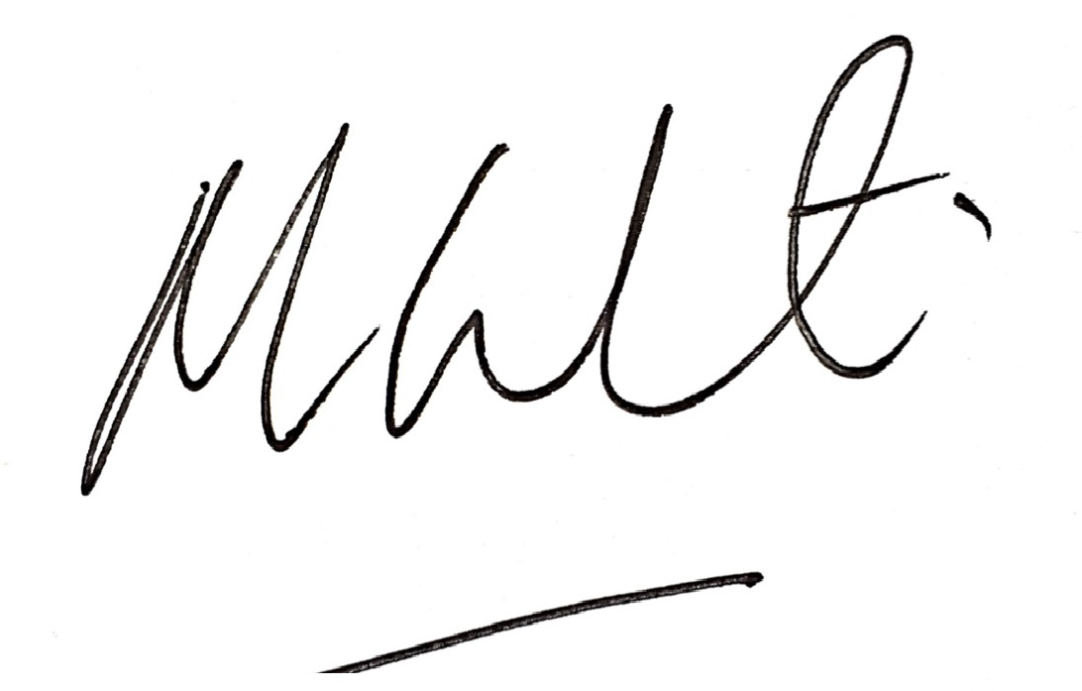  Date: 2 September 2020  Reviewed 11 June 2021  Please note an electronic signature will suffice.

