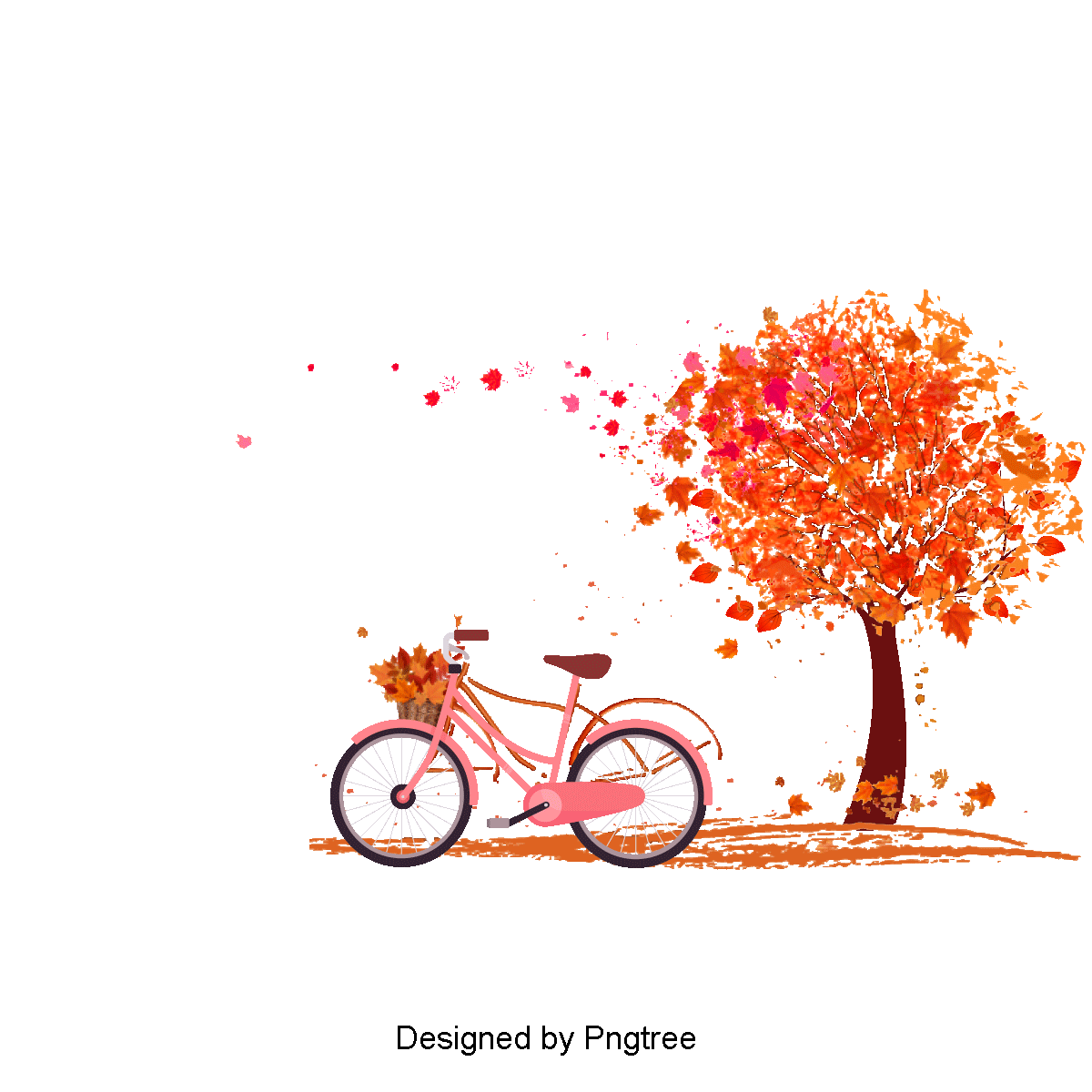

**English**

We are following a novel based approach this year. Our first novel is Street Child and we will cover the topics of balanced arguments, recounts and poetry. We will also be covering grammar, punctuation and spelling objectives.

**Science**

**Evolution and inheritance** - Pupils will be taught recognise that living things have changed over time and that fossils provide information about living things that inhabited the Earth millions of years ago

**Physical Education**

**Dodgeball- This term we will focus on team work and develop throwing and hitting skills.**

**Gymnastics- We will focus on developing the basic shapes and jumps involved in creating routines.**

**Dates for your diary**

24th September- Maths Party Day

19th and 20th October- Parent’s Evening

**September-October 2014**

**Thank you for your support**

Homework – Year 6 homework will start this week. Please see the letter to parents, which details the

homework timetable. Homework will always reinforce the work that we have covered in class and we will endeavour

to make it as ‘family friendly’ as possible and hope that you can do your bit to support learning at home.

**Art**

Drawing – pupils will be taught to draw from different perspectives using line, edges and shading with wet and dry materials

**Humanities**

**Geographical skills – The pupils will be developing skills such as reading and understanding OS maps; using atlases to locate countries and geographical features; and drawing increasing detailed sketch maps**

**History- We will focus on the Greek civilisation and examine how it differs to other time periods that we have studied.**

**Religious Education**

Domestic Church- Family- Loving - Students will focus on the relationship between the domestic church and the family union. They will share their experiences of Church through their own spiritual understanding of the topics covered.

**Mathematics**

For this first half term, pupils will concentrate on refining their mental maths skills, concentrating on number, place value and the four operations. There will be plenty of practical opportunities to solve a range of mathematical problems. Please help your children to learn their times tables up 12 x 12 and the corresponding division facts.



**Year 6**

**Autumn Term 1**

**September-October 2021**