

**Learning Journey**

**Year 1**

**Autumn Half Term 2**

**November-December 2021**

**Phonics and Spelling**

Children will continue with the Read, Write, Inc phonics scheme. Children will be tested on their spellings every Monday. The spellings lists follow the pattern of the Read, Write, Inc scheme and include the high frequency words for Year 1.

Spelling Shed is a really good interactive resource to help the children learn their spelling words.

**Religious Education**

This term we are continuing with the topic ‘Belonging’. We will be exploring Baptism and how it enables people to belong to God’s family in a special way. We will then be moving on to ‘Waiting’. This involves us learning all about Advent, a time of waiting to celebrate Jesus’ coming at Christmas.

**Physical Education**

In our PE lessons we will be exploring basic movement through gymnastics and dance.

**Maths**

Our Maths learning will include…

* Addition and subtraction within 20.
* Identifying and comparing number bonds to 10 and 20.
* Fact families – the 8 facts.
* Comparing addition and subtraction facts.
* Recognise and name 2D and 3D shapes.
* Sort 2D and 3D shapes.

**Design Technology**

This half term we will be designing, making and evaluating our own pull along toys.

**History**

In our topic work we will be exploring ‘Toys from the Past.’ We will be comparing toys from the past with those of today. If any parents or grandparents still have any of their old toys it would be great to share them with the class.



**Science**

In Science we will be looking at the human body, naming bones and finding out what they do.

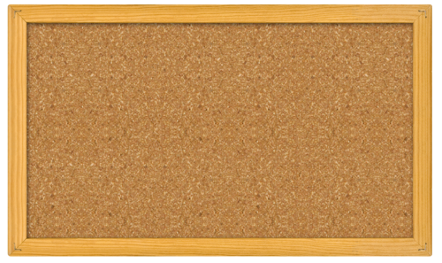

**Notices**

**PE is on a Tuesday and a Thursday, please ensure children come to school in the correct PE kit.**

**Please ensure that your child’s reading bag and book are brought into school on a Friday to allow us to change their books.**



**English**

In English we will be focussing on the Funny bones story by Janet and Allan Ahlberg. We will also look at linked texts to capture the children’s imaginations. We will be studying story settings and descriptions.





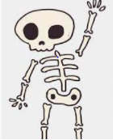

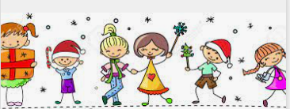



**Dates for the Diary**

1st-5th November- Liverpool Music week

8th-12th November- Maths week

15th December- KS1 Party Day

**Reading**

Just a reminder that books will be changed once a week. Books must be brought in on a Friday to be changed and will be given back out on a Monday. Children will only be given one book to read per week. We encourage you to read a range of genres at home, including comics and factual books. Below are some ideas to help when hearing your child read their school books each day….

|  |  |
| --- | --- |
| Monday | First read of story. Use Fred fingers to help decode unfamiliar words independently. |
| Tuesday | Read words out of context and talk about any new or tricky words. |
| Wednesday | Second read of story. Discuss the characters in the story, plot, settings etc. |
| Thursday | Read a page each of the story, use different voices for different characters. Identify and discuss the punctuation within the text. |

**Music**

This half term we will be practising for our Christmas production; to which we hope you will be invited! More information will be given once we are able to confirm families can attend.



**P.S.H.E. / R.S.H.E.**

Celebrating difference – Following the Jigsaw scheme of work, the children will find out that sometimes people make assumptions about boys and girls (stereotypes), understand that bullying is sometimes about difference. The children will also look at strategies for making new friends and be able recognise some ways that they are different from their friends.

Journey In Love - Year 1 will focus on the idea that they are loved in their family.

No Outsiders –Through stories and discussion, the children will accept and like the way they are and will learn to play with both boys and girls.



Anti-Bullying Week – 15th– 19th November

Road Safety Week 15th – 21st November