
Risk Assessment

A | Date: 28 February 2022 | School: Much Woolton Catholic Primary | Team: | Location:
 | Review Date: monthly | Ref: | Assessor: M White/ M Wilson | Head Teacher: M White

B | Assessment of Risk for: Protection from transmission of COVID-19 – Schools

C | List Hazards Here | List Groups of  People at Risk | List Existing Controls | Risk Level
Ser Nº
1 | COVID-19: General | Staff  Pupils  Visitors  Contractors | All staff are competent and instructed with regard to the procedures in place for the protection against infection from the virus.  There is adequate supervision, where required, to ensure procedures are correctly adhered to.  Reference School infection control risk assessment, as required: RA29  Pupils and staff who are symptomatic will be requested to isolate as per national guidance.  Managers must also review all of the following applicable individual risk assessments where relevant:  - New and expectant mothers  - Extended duty of care  - Stress  - Individual pupil assessments  Manager to regularly update and inform staff re government guidance regarding COVID-19 controls required:  - Gov.uk www.gov.uk/government/collections/guidance-for-schools-coronavirus-covid-19  - Gov.uk Public Health England https://www.gov.uk/government/organisations/public-health-england  - Health and Safety Executive https://www.hse.gov.uk/  Referring to the following guidance and publications, as applicable:  - HSE COVID19 latest information and advice  - HSE Working safely during the coronavirus guide  - Government guidance COVID-19: guidance for schools COVID-19  - Government publication COVID-19: cleaning in non-healthcare settings  - Government publication Best Practice: how to hand wash  - Government guidance for food business on Coronavirus (COVID-19)  - Government guidance COVID-19: Safe working in education, childcare and children’s social care settings, including the use of personal protective equipment (PPE)  Due to the changing advice on COVID-19, managers should ensure they review safe working procedures and protocols regularly, until such time when it is unnecessary.  Staff should undertake LFT tests if feeling unwell or demonstrating classic symptoms of COVID-19.  Face coverings  Staff are no longer required to wear face coverings on site, however those who wish to, should and should not be discouraged from doing so. Face coverings also help stem the spread of other airborn viruses so those who feel unwell but test negative for COVID -19 may wish to wear a face covering to prevent the spread of germs and viruses.  Positive cases  Staff and children who test positive must stay at home. All are asked to follow the pathway below before returning to school:  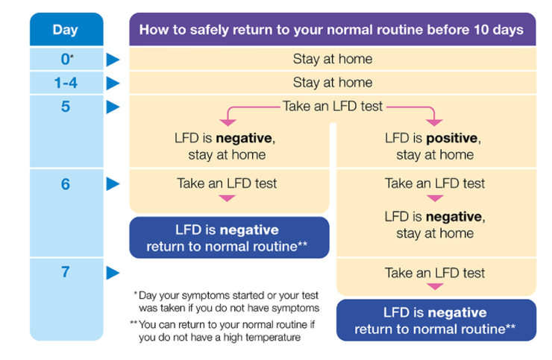  Staff and children may return to school on day 7 if they have had 2 negative tests on days 5 and 6. Failing this, they may return to school after day 7 following 2 consecutive days of negative tests or on day 11, whichever comes first.  PPE  PPE provided, as required following specific current guidance for the protection of COVID-19 detail type and standard, as applicable:  - Disposable half face mask  - Disposable gloves  - Disposable aprons  - Where personal care is to be provided eye protection/surgical face mask  - detail any other specific disposable PPE in use  All used PPE should be double bagged and disposed of appropriately – store safely and securely for at least 72hrs before disposing via the normal waste stream.  All staff informed that hands should be washed regularly as per Government guidance.  Pupils regularly reminded, in age appropriate ways, that hands should be regularly washed as per Government guidance.  Signage around school encouraging staff and pupils to maintain good hand hygiene.  School encourages good respiratory hygiene by promoting ‘catch it, bin it, kill it’. Posters displayed in prominent areas and toilets.  Staff kept informed via email, online meetings etc.  Post-incident de-briefing carried out for anyone involved in an incident of suspected contamination, with the aim of providing support and preventing incident recurrence. Further support provided to all staff members affected by the incident.  All incidents reported to the Health and Safety Unit as per the school accident and incident reporting procedure using the LCC online accident and incident report form.  Reference made to HSE guidance for reporting under RIDDOR:  - HSE RIDDOR reporting of COVID-19 | Low  Low  Low  Low  Low  Low  Low  Low  Low  Low  Low  Low  Low  Low  Low  Low  Low  Low  Low  Low  Low
2 | COVID-19; General school environment | Staff  Pupils  Visitors  Contractors | School first aid risk assessment reviewed, as required: FA1  School access control system reviewed and appropriate steps taken e.g. hand sanitizer located at entrance for staff/visitors to cleanse hands after use, wipes available to cleanse keypads and touchscreens.  Hand sanitizer stations located at:  - Entrances to building  - Classrooms/entrances to classrooms  - Corridors  - Staff rooms  - Toilets  - Changing areas  Signage installed to various areas of the building reminding people to wash hands regularly, in line with Government guidance.  Corridors, walkways and staircases have markings laid out to indicate side to walk on (two way traffic).  Staff verbally reinforce controls in corridors, walkways and stairwells where necessary.  Wipes and cleaning materials available in staff rooms for staff to clean regular contact points e.g. kettle, taps etc.  Senior leadership to check ventilation throughout the day  Staff numbers are no longer limited in the staff room or offices, however this remains subject to review. All rooms must be adequately ventilated. | Low  Low  Low  Low  Low  Low  Low  Low
3 | COVID-19: School reception and offices | Pupils  Visitors  Contractors | Staff are requested to send information electronically to avoid the use of internal mail services.  All returned visitor passes, keys or fobs are kept stored separately from other items and cleaned and sanitised before reissue.  Windows will be opened where practical, to encourage as much natural ventilation as possible  Staff to clean and sanitise their workstation (including chair arms) at the beginning and end of their daily shift. Additional cleaning stations are to be provided for staff to use and replenished as required. | Low  Low  Low  Low  Low  Low
4 | COVID-19: Meetings | Staff  Pupils  Visitors  Contractors | Wherever possible, meeting rooms should be adequately ventilated with external windows opened during meetings.  Whole school meetings (e.g. inset day) to be held in as large a space as possible to allow for adequate distancing of attendees:  If adequate spacing between attendees cannot be achieved, the wearing of face coverings is encouraged.  Meeting room users advised not to share equipment during meetings i.e. pens, stationery etc. Attendees to remove all items following the meeting.  Meeting room users to wipe down surfaces (including any buttons on IT equipment and remote controls) following meetings. Additional cleaning materials will be provided in all meeting rooms for use by staff and replenished as required.  Meetings to take place promptly and conclude fully in the meeting room to avoid attendees congregating in adjoining areas prior to and following meetings.  Meeting room should be aired thoroughly on completion of the meeting e.g. opening windows fully.  Parent group meetings:  - Individual meetings with parents to be held in a well ventilated room. Where possible, ask parents to take a LF test prior to the meeting and share with staff present the outcome of the test.  - Indoor parent groups numbers are restricted appropriate to room size etc.  .  Parents are granted access at 3.30pm to limit time congregating on site. All parents follow one way system for pick up. | Low  Low  Low
5 | COVID-19: Classrooms | Staff  Pupils | For individual and very frequently used equipment, such as pencils and pens, staff and pupils have their own which are not shared.  Cleaning of hands is encouraged when changing classrooms for different activities.  Classroom windows will be opened, where practical, to encourage as much natural ventilation as possible.  Classrooms should be aired thoroughly when empty e.g. opening windows fully. | Low
6 | COVID-19: Dining areas | Staff  Pupils | Dining room windows will be opened to allow natural ventilation. | Low
7 | COVID-19; Cleaning | Staff  Pupils  Visitors  Contractors | All cleaning staff are experienced and have received appropriate training.  Any new cleaning products brought on site in response to the current COVID-19 pandemic will have a COSHH risk assessment undertaken prior to use.  Cleaners have appropriate PPE in line with COSHH risk assessments  Classroom play equipment wiped down and cleansed at the end of the school day and between activities where possible.  Cleaning undertaken in line with Government publication COVID-19: cleaning in non-healthcare settings.  School will be fully cleaned at the start/finish of each school day.  Classrooms where a pupil or staff member has become symptomatic during the school day will be deep cleaned along with other areas the person may have been. | Low  Low  Low  Low  Low  Low  Low
8 | COVID-19; Ventilation | Staff  Pupils  Visitors  Contractors | Staff are encouraged to open windows and doors (not fire doors) to encourage as much natural ventilation as possible.  When leaving a classroom empty, windows should be opened fully to purge the room then left ajar when the room is re-occupied.  Desk type fans can be used to promote fresh air flow from an open window.  Fans should not be used in poorly ventilated areas.  Prior to the receipt of CO2 monitor re Government roll out: potentially poorly ventilated areas identified, including all areas where people work/teach and have large groups within, that have no mechanical or natural ventilation.  Steps taken to improve ventilation or reduce occupancy/use of the area:  List poorly ventilated rooms and detail controls taken to reduce risk e.g.  - Limit numbers entering and working within  - Reduce time spent in area  - Door kept open whilst within and left open when leaving to air room (unless fire door) | Low
9 | COVID-19; Pupils and staff who become symptomatic during the school day | Staff  Pupils  Visitors  Contractors | Pupils and Staff who become symptomatic during the school day will be isolated from the rest of the pupil group and their parents (pupils) will be called to come and collect them. Staff will be sent home to self-isolate/follow public health advice.  If a symptomatic pupil is awaiting collection, appropriate PPE should be used if close contact is necessary.  Any areas, items and surfaces the symptomatic person has come into contact with should be thoroughly cleaned as soon as possible.  Symptomatic pupils and staff are advised to engage with NHS Test and Trace and get tested and to follow the current advice.  Staff and pupils with a positive LFT test result should stay at home in line with COVID-19 guidance for household with possible coronavirus infection.  School should complete online MDS form if there is a confirmed case associated with their setting https://www.smartsurvey.co.uk/s/covid-19-schools/  School should contact local authority SPOC team if they have a positive case. They will liaise local health protection team where necessary and advise if any additional action is required, such as implementing elements of your outbreak management plan. Further advice is available through the DfE helpline on 0800 046 8687 and selecting option 1 for advice on the action to take in response. | Low  Low
10 | COVID-19; Outbreaks | Staff  Pupils  Visitors  Contractors | Schools has an outbreak management plan covering the possibility that bubbles and all previous social distancing controls may be reintroduced locally due to an raised COVID cases locally.  School should complete online MDS form if there is a confirmed case associated with their setting https://www.smartsurvey.co.uk/s/covid-19-schools/  School should contact local authority SPOC team if they have outbreak concerns. They will liaise local health protection team where necessary and advise if any additional action is required, such as implementing elements of your outbreak management plan. Further advice is available through the DfE helpline on 0800 046 8687 and selecting option 1 for advice on the action to take in response | Low
Risk Level: High: Accident likely with possibility of serious injury or loss
Medium: Possibility of accident occurring causing minor injury or loss
Low: Accident unlikely with control measures in place

D | Controls | E To be completed by the Manager
 | (Ser N^{º} to correspond with Hazard Ser N^{º})
Ser Nº | Additional Controls Required | Action to be Taken | By Whom | Target Completion Date | Task Completed  (Signed & Dated)
- . | Ventilation and hand sanitiser checks | Leadership to conduct spot checks on ventilation and pupil voice checks on hand sanitisation procedures | SLT | Daily

F | Once additional controls are implemented, what will the overall risk level be:  High Medium Low | Risk assessment signed off by:  Signature: 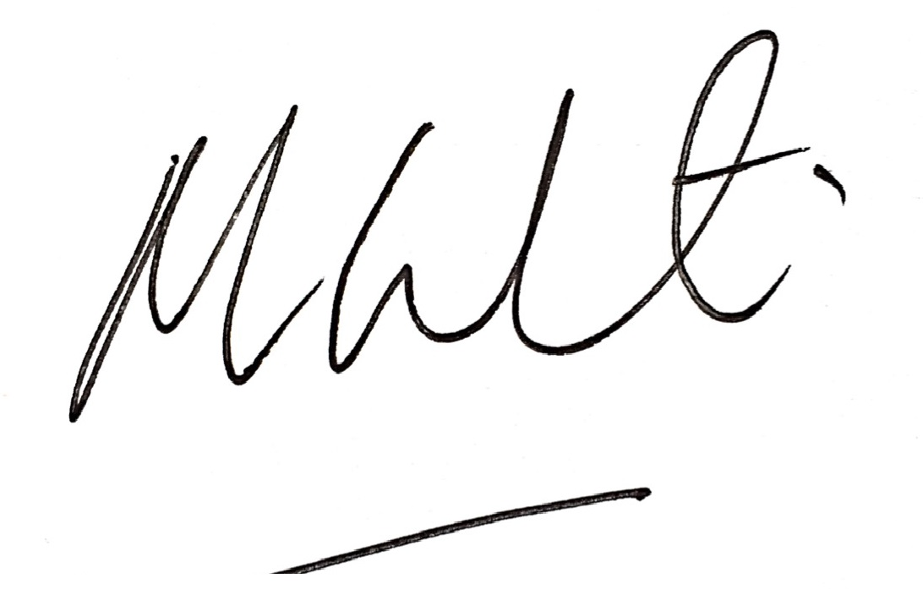  Date: 28022022  Please note an electronic signature will suffice.

