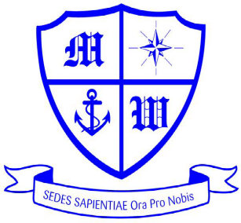
Much Woolton Catholic Primary School
Watergate Lane, Woolton, Liverpool L25 8QH
Headteacher: Mr M White

 0151 428 6114

www.muchwoolton.co.uk With Jesus we love, learn and grow

EYFS Museum of Liverpool - 27.05.22
Dear Families,

Class 1 will be visiting the Museum of Liverpool on Friday 27th May. The children have really enjoyed learning about how water is used in a variety of ways, and we thought this would be a great place to visit.

Children should come into school through their normal gate at 8.45 (not via the office) to be registered, toileted and ready to leave at 9.30. We will not be able to wait for latecomers. We will return to school by 3.30pm. Children will all be provided with a school packed lunch. and all children should wear their school uniform for the trip.

The total cost for the trip is £10.00 and the contribution for Pupil Premium pupils is £5.00 and should be paid for via Parent Pay. This is a voluntary contribution in line with our charging policy; however, should we not receive sufficient funds the trip may have to be cancelled. Please complete the slip below and return to your child’s class teacher no later than Thursday 19th May 2022. Payments must be made by Friday 20th May.

Many thanks,

Mrs Doherty

Much Woolton Catholic Primary School
Payment / Lunches / Permission Slip
PLEASE RETURN THIS PAGE TO SCHOOL

Museum of Liverpool Trip 27.05.22 Class 2

Child’s Name____________________________________________ Class_______

I will make the voluntary contribution of £ 10.00 by 20.05.22 [ ] Please tick

I will make the voluntary contribution of £ 5.00 by 20.05.22 [ ] Please tick

I give permission for my child ___________________________________________ Class ________

to visit the Museum of Liverpool on 27.05.22. I understand that if sufficient funds aren’t received for the trip, it will be cancelled.

Signed _________________________________________________________ Date: ____________________

Emergency Contact Number: _______________________________________

