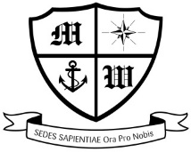Much Woolton Catholic Primary school

‘With Jesus we love, learn and grow’

History Long Term Map 2022-2023 – Ark Curriculum

|  |  |  |  |
| --- | --- | --- | --- |
|  | Autumn Term | Spring Term | Summer Term |
| Foundation | Nursery Rhymes | Myself | The Changing Year |
| Year 1 | Toys in time | Transport and Travel | Our Seaside: Now and then |
| Year 2 | Kings and Queens | The Great Fire of London | They made a difference |
| Year 3 | Stone, Bronze and Iron Age |  | Ancient Greeks |
| Year 4 | Romans Invasions | Roman Britain | Maya Civilisation |
| Year 5 | Anglo Saxons & Scots | Vikings | The Industrial Revolution |
| Year 6 | Ancient Egyptians | Conflict and Resolution | Making our Mark  (Social justice) |