Homework – Set 1
Scan the QR codes with a device and watch the videos at home regularly for extra reading practice!
(These QR codes will expire on 17th July 2023).
Practise reading the Set 1

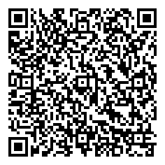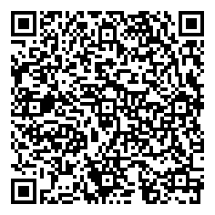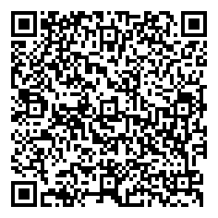
m, a,s,d,t. i,n,p,g,o. c,k,u,b,f
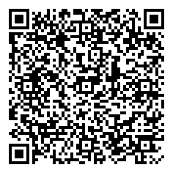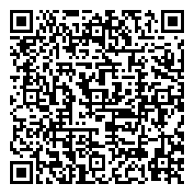
e, l,h,r,j. v,y,w,z,x

Word time – practise reading
