Homework – Set 3
Scan the QR codes with a device and watch the videos at home regularly for extra reading practice!
(These QR codes will expire on 17th July 2023).
Practise reading the Set 3

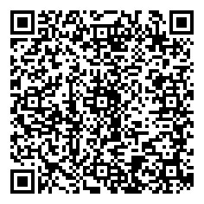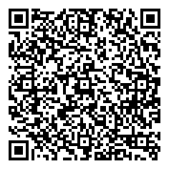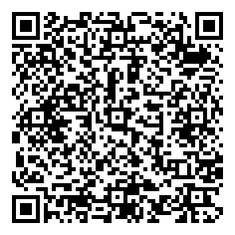

Ea, io, a-e, i-e, o-e. u-e, aw, are, ur, er. ow, ai, oa, ew, ire
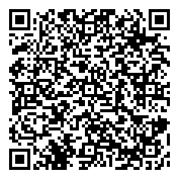ear, ure, tion, tious

